Date of Creation : October 10, 2022

|  |  |  |  |  |  |  |
| --- | --- | --- | --- | --- | --- | --- |
| NO PO | DESCRIPTION | PERIOD | PO VALUE | USAGE | BALANCE | GR VALUE |
| 8000034121 | Svc SDP  Testing | Sep 22 | 100.000.000 | 20.000.000 | 60.000.000 | 20.000.000 |

Supplier Name : PT. IDStar Cipta Teknologi

Project Location : Jakarta

Work Completed : Partial

Type of Project : Services

Requisitioned : -

Delivery Date (for Material) : -

Receipt Date (for Material) : -

**Certification:**

This is to certify that PT XL Axiata Tbk has accepted the Product or Services as identified in Purchase Order referenced above.

With the approval by both party, The Supplier entitle to issue invoice starting from the date of vendor approved date and PT XL Axiata Tbk will release payment as stated in the **Value of GR**.

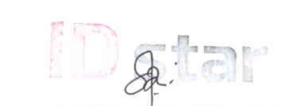

**Dewi Ani _______________________________**

Finance Manager Date: 10 October 2022

**Ratna Tri Wulandari** _______________________________

Date: